MACH4METAL

metalworking machinery
Transito 21,
6909 DA BABBERICH, Netherlands
Tel. + 31 (0)316 – 247123
Fax. + 31 (0)316 - 247956
info@mach4metal.com
www.mach4metal.com

Bank No : 66.52.13.883
IBAN : NL33 INGB 0665 2138 83
BIC : INGBNL2A

MEBA BAND SAWING 335 DGA 1000
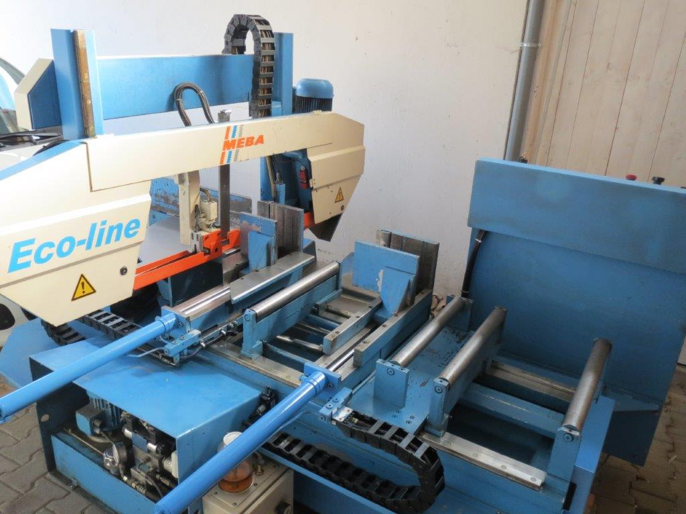
- Make : MEBA Germany
- Type : 335 DGA 1000
- Age : 2001
- Mach. No. : 6675

Cutting capacity 90 °
- Max. Ø : 335
- Max. height : 500
- Max. width : 335

Cutting capacity R 45 °
- Max. Ø : 330
- Max. height : 320
- Max. width : 335

Cutting capacity L 45 °
- Max. Ø : 305
- Max. height : 305
- Max. width : 335

- Cutting speed : 18 – 115 M/Min
- Blade size : 4400 x 34 x 1,1

- Auto feed length single : 0 – 1000 mm
- Auto feed length multiple : 0 – 9999 mmm

- Dimensions
- Length : 2.680
- Width : 2.350
- Height : 1.900
- Weight : 2.000
- Power : 2.2 kW

Please Note: The above information has been obtained to the best of our ability and belief from, and from the manufacturers where possible. It is given in good faith, but its accuracy can not be guaranteed. Accordingly, it will not form a representation or constitute contractual terms. We advise you to check any vital deta

